V 1/2014
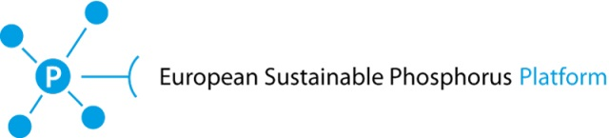

Interim period contribution levels: For the ESPP interim setting-up period (Summer 2013 – Spring 2014 approximately): €10,000 for national governments ; €6,000 for companies, industry associations* ; €2,000 for knowledge institutes*, NGOs*, small businesses and other types of organizations*.
* = contribution in kind may be possible where indicated * only.
Conditions for partnership after the interim period (once the Platform is formally defined and established) will be decided during the interim period and may be different.

Organisations wishing to be an interim period partner through in kind contribution (rather than a cash payment) must provide and document one or more of the following:

bring to the Platform a paying company or government partner

ensure equivalent of the partnership fee through project funding or similar
Eg. by including a budget for Platform core activities in a project proposal or consortium. The partnership contribution will be calculated as the contribution to Platform core activities (e.g. staff time for dissemination, networking, expertise). net of additional costs implied for the Platform (eg. travel, meeting costs). It is recognised that projects may have a significant delay time (preparation, submission, funding decision) and therefore applications based on project proposals will be considered. The Platform should always be consulted before including it in any proposal submission.

provide in-kind services of value equivalent to the partnership fee, subject to acceptance by the Platform that the proposal corresponds to services relevant and needed.
Participation of partner personnel at meetings etc cannot be considered as an in-kind contribution, only specific services which effectively save the Platform external costs (communications, workshop costs, …). Proposals will only be accepted if the Platform considers that the proposed service is needed by the Platform, and so the in-kind contribution reduces Platform spending.

In all cases, the contribution in kind must be documented and justified using this form

Return this form, in electronic format (PDF or WORD) to the ESPP secretariat info@phosphorusplatform.org
Please use additional pages or include annexed PDF documents, if useful.
Acceptance or not of the application will be made by decision of ESPP’s partners already to date.

Applicant organisation name :
Location(s): town/country:

Contact person: name, telephone, email

Experience / competence of your organisation relevant to sustainable phosphorus management:
(approx. one half page total. If appropriate, please indicate ongoing or recent projects with websites or references. Include additional pages or provide more detailed information in accompanying documentation if useful)

You must tick and complete one of the following options (a – d)
[ ] (a) Payment in Euros: 2 000 € for knowledge institutes:
In this case, please indicate :
legal address for invoice:

[ ] EU VAT number ………………………………………………………. or [ ] NOT subject to VAT

[ ] (b) Accompanying company or government expected to become paying Platform partner:
Please provide organisation name, and contact person (with email telephone) to whom Platform partnership contract should be sent.
Please specify date on which this company or government confirmed agreement in principle to become a Platform partner

[ ] (c) Proposed project/consortium in which funding is included for Platform activities:
Please summarise in a few lines the services/role proposed for the Platform and the budget for these for the Platform (a. total; b. contribution to Platform core activities; c. external costs). Please specify status of project (proposal/ accepted/ …) and calendar for submission, acceptance, implementation. Please annex full project proposal and budget or equivalent.

[ ] (d) Proposed services or other contributions in kind:
Approx. quarter to half page, please indicate estimated value item by item of services/input proposed and specify relevance for Platform activities

